



Presentation

**Name: Muhammad Danyal**

**Reg.No: 4304-BSSE-F21-B**

**Name: Furqan Ahmad Yousafzai**

**Reg.No: 4334-BSSE-F21-B**

**Name: Khalid Khan**

**Reg.No: 4362-BSSE-F21-B**

**Name: Nabeel Ahmad**

**Reg.No: 4315-BSSE-F21-B**

**Name: Abid Hakimi**

**Reg.No: 4363-BSSE-F21-B**

**Submitted To: Sir Shakir Rasheed Khan Khatttak**

**Use case of Doctor Appointment System (Health care):**

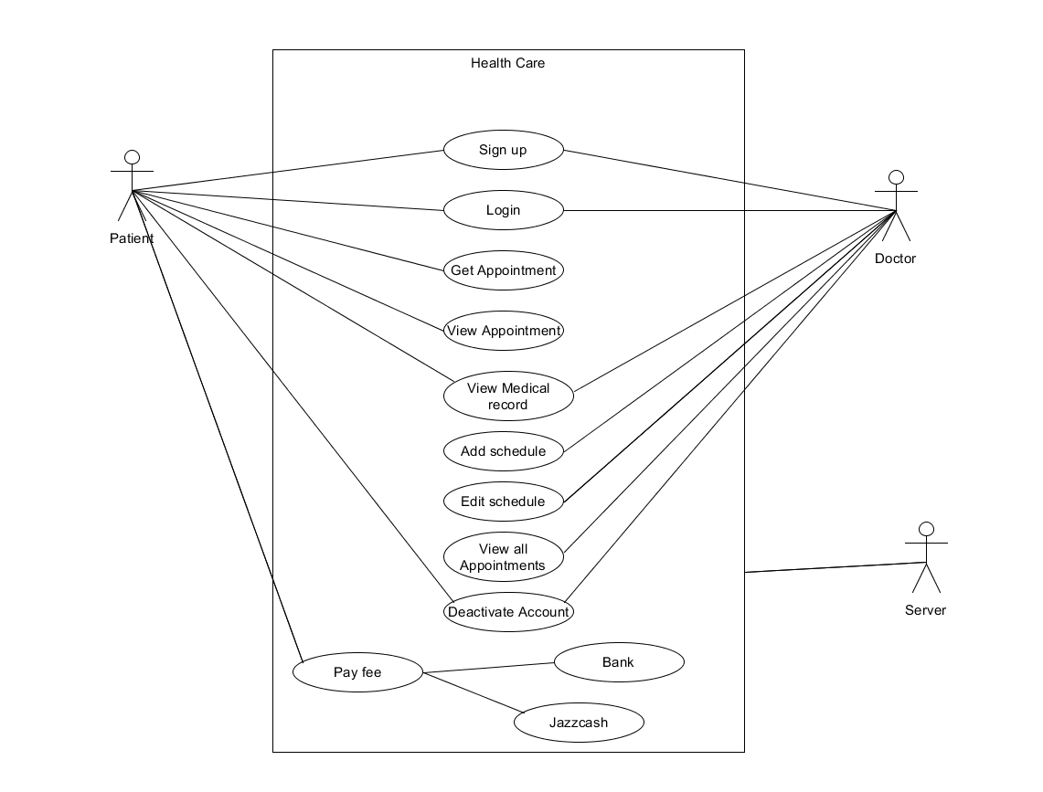

**Domain Model of Health Care :**

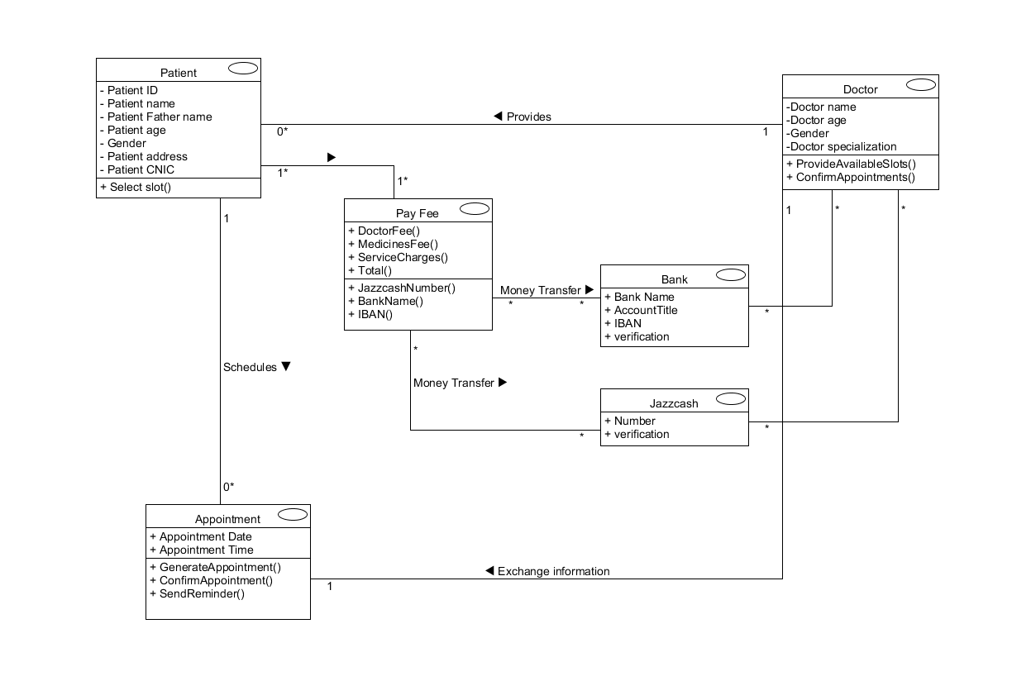

Finished